Tổng hợp

MẸO
Chỉ cần học 1 mục true hoặc false ít nhất là được → mẹo

TRUE

Q1. True or False: You should compare your project performance against the performance measurement baseline to look for potential changes in the project.
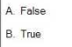
B. True

Q2. True or False: The Project Charter is a document issued by the project initiator or sponsor that formally authorizes the existence of a project. It provides the project manager with the authority to apply organizational resources to project activities.

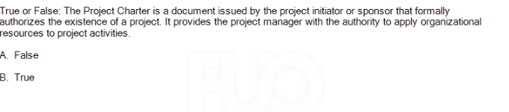
B. True

Q3. True or False: Project Manager should consider using milestones for high level reporting.
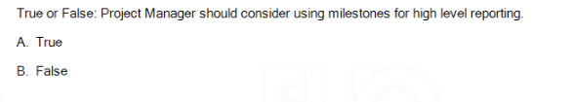
A. True

Q4. True or False: The critical path is made up by all zero float activities (activities have floats equal to zero) in the project network diagram.

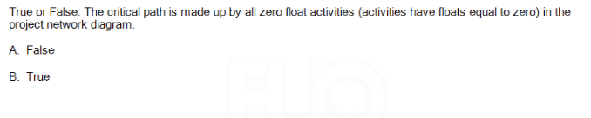
B. True

Q5. True or False: The Backward Pass is used through the activities to determine the critical path & available float of the project.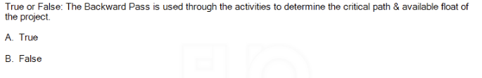
A. True

The Backward Pass is used in project scheduling to calculate the late start (LS) and late finish (LF) times for each activity. This helps determine the critical path (activities with zero float) and the available float (slack time) for non-critical activities in the project. The backward pass starts from the project's end date and moves backward through the network diagram.
Q6. True or False: The S-Curve depicts the relationship between the cost baseline budget and the schedule because it shows the planned cost baseline budget across the planned project timeline.

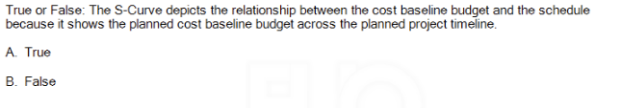
A. True

Q7. True or False: Performing quality assurance within the context of a project involves applying the planned,systematic quality activities to ensure that the project correctly employs all processes needed to meet project objectives and product requirements.
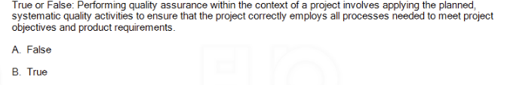
B. True

Q8. True or False: Effective project communication management creates a bridge between stakeholders based on a shared understanding of the project and the ongoing sharing of information needed for its success.

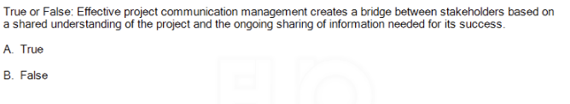
A. True

Q9 : True or False: If "develop online modules" needs to finish before "review online modules" can finish, that is called a finish to finish relationship.

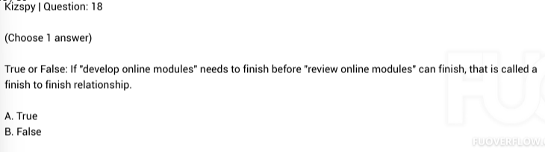
A. True

Q10: True or False: The Cost Baseline is equal to the total of Activity Cost Estimates plus Contingency Reserves.
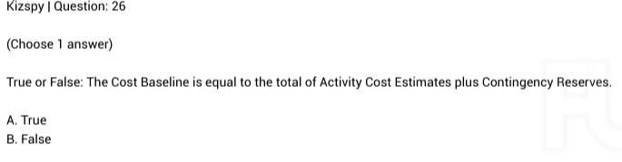
A. True

Q11 : True or False: Project quality focuses on the project management processes used to meet project objectives.
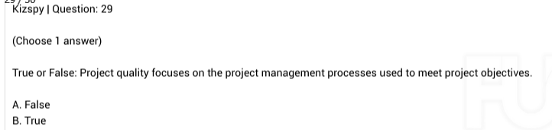
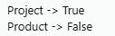
B. True

Q12: True or False: The Process Improvement Plan is a component of the project management plan that details how project management and development processes are to be analyzed in order to identify how to increase their value.
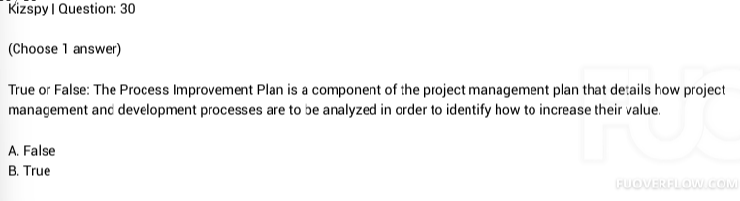
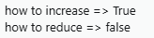
B. True

Q13: True or False: Performing quality assurance within the context of a project involves taking actions to eliminate causes of unsatisfactory project performance.
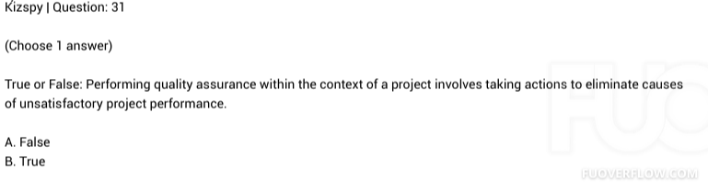
B. True

Q14: True or False: Performing quality control within the context of a project involves taking actions to eliminate causes of unsatisfactory project performance.

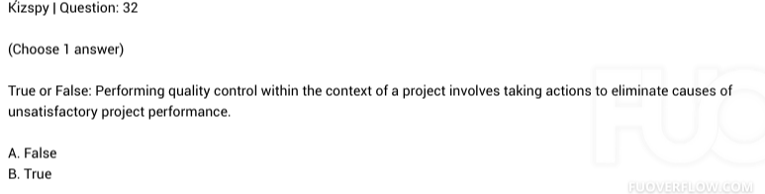
B. True

Q15: Project Human Resource Management includes the processes that define the tasks and assign them to suitable resources, and motivate project team to complete the tasks
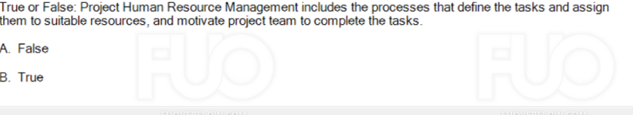
B. True

Q16: True Or False, a project manager spend most of his/her time communicating

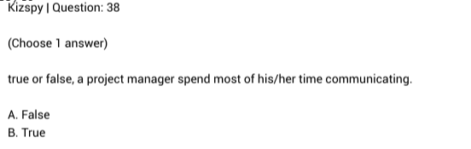
B. True

Q17 : True or False: A positive risk is an opportunity; a negative risk is a threat.
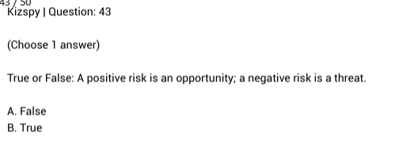
B. True

Q18 : True or False: The Project Manager is responsible for stakeholder expectations management.
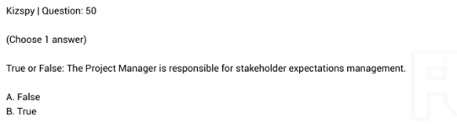
B. True

Q19: The primary output from the identification of risks is the risk register.

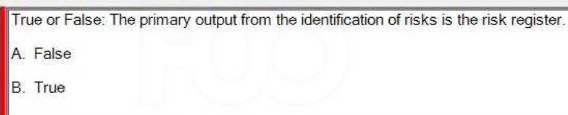
B. True
Q20 True or False: Performing quality control within the context of a project involves applying the planned,systematic quality activities to ensure that the project correctly employs all processes needed to meet project objectives and product requirements.
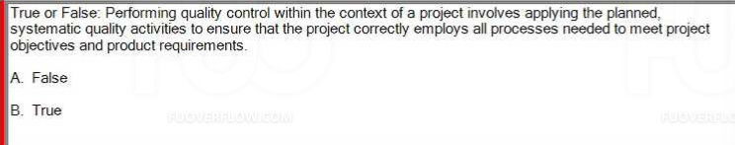
B. True

Q21 - True or False: If you are not certain who your stakeholders are, asking who will use the product or service being created can be helpful.
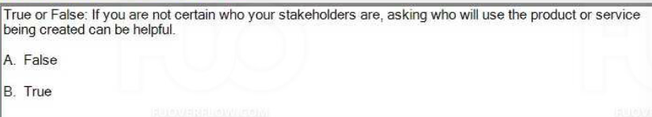

B. True

Q22. True or False: Your role as the project manager during quality control is to implement the quality management plan using the appropriate tools and techniques, in order to ensure that work is being performed according to required quality standards
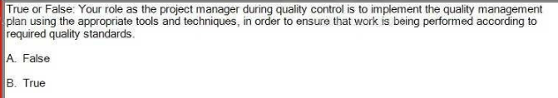
B. True

Q23. True or false, a project manager spend most of his/her time communicating

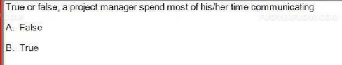
B. True

Q24. True or False: Performance reporting aims to inform stakeholders how resources are being used to achieve the project's objectives.
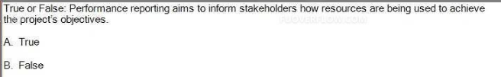
A. True

Q25. True or False: If "develop online modules" needs to begin before "review online modules" can begin, that is called a start to start relationship.
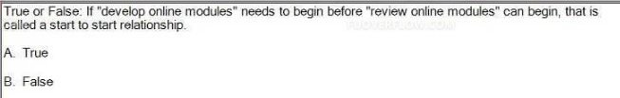
A. True

Q26. True or False: A Work Breakdown Structure (WBS) is a deliverable-oriented hierarchical decomposition of the work to be executed by the project team.
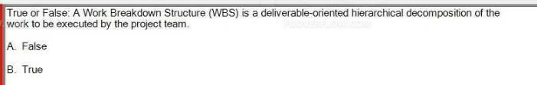
project team -> true
project manager -> false
B. True

Q27. True or False: Project Human Resource Management includes the processes that organize, manage, and lead the project team.
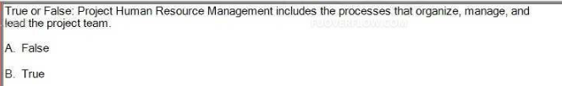
B. True

Q28 .True or False: Conflict management is the process by which the project manager uses appropriate managerial techniques to deal with the inevitable disagreements that develop among those working toward project accomplishment.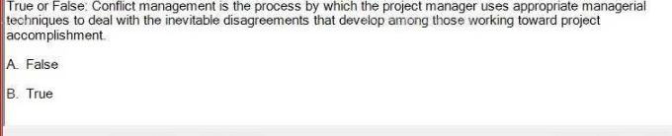
B. True

Q29 : True or False: Project scope statement is better to define inclusions (in-scope items) than identify only exclusions (out of scope items).
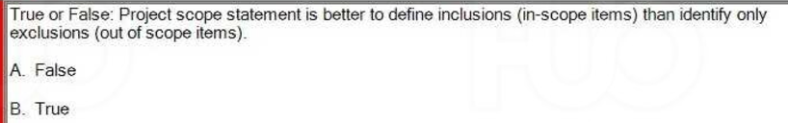
B. True
Q30 : True or False: Your project might pay more in order to reduce the schedule when using Crashing approach, but that is not often true if using Fast Tracking approach.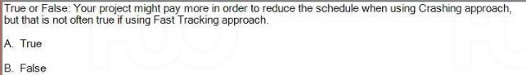
A. True

Q31. True or False: Product quality focuses on the goods and services.
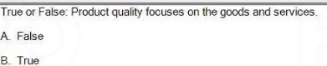
B. True
Product => True
Project =>False

Q32. True or False: The Project Budget is equal to the Cost Baseline budget plus Management Reserve.
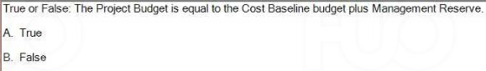
A. True

Q33. True or False: The Forward Pass is used through the activities to determine the critical path & available float of the project.
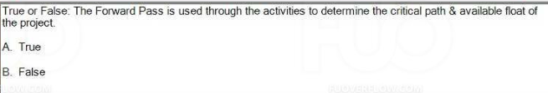
A. False

Q34. True or False: When it comes to projects, the emphasis is on strategic quality management. Quality is not an accident, quality is part of the plan, and quality is everyone's job.
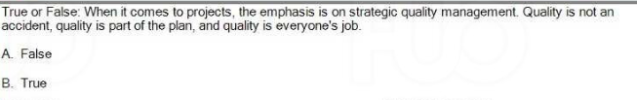
B. True

Q35- True or False: The danger of estimating using the same parametric model is the no longer applicable of historical data.
I
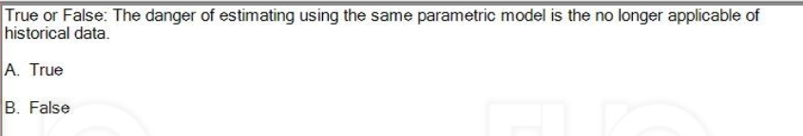
A. True

Q36 : True or False: When you choose to transfer your project risk to a third party, it will definitely rise to secondary risk.
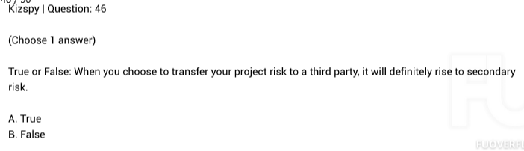

A. False chư

Q37 True or False: Your role as the project manager during quality assurance is to implement the quality management plan using the appropriate tools and techniques, in order to ensure that work is being performed according to required quality standards
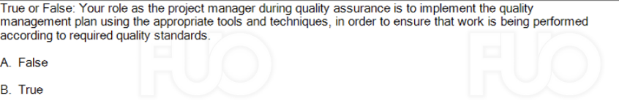
B. True

Q38 True or False: Authority means you have the right to apply resources, make decisions and give approvals.
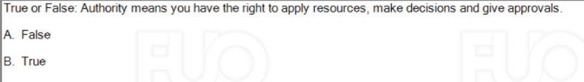
B. True

Q39 True or False: Project Cost Management processes aim to help the project can be completed within the approved budget.
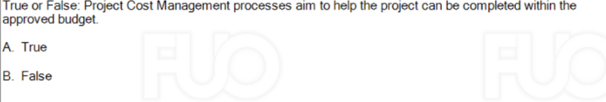
A. True
Q40 - True or False: Earned value integrates quality, scope and schedule and uses monetary values to assess project status.
A. False
B. True

Q41 True or False: The Project Charter is a document that formally authorizes the existence of a project. It also document initial requirements that satisfy the stakeholder's needs and expectations.
A. False
B. True

Q42 True or False: Using bottom-up estimating techniques when the detail is available and the accuracy is needed.
A. True
B. False
(100%)
Q43 True or False: The sender is responsible to make the information clear, complete, and appropriate to the needs of the receiver. The receiver is responsible to provide feedback to acknowledge that the message has
been received and understood.
A. True
B. False
(100%)

Q44 True or False: Your role as the project manager during quality assurance is to work with a quality assurance manager who will create a test plan and test cases which will be used to test the product you are creating in order to prevent defects from reaching your customer.
A. False
B. True

FALSE
Q1: True or False: Project quality focuses on the goods and services.
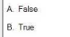
A. False
Q2: True or False: Quality management is the job done by project manager himself/herself to determine quality policies, objectives, and responsibilities so that the project will satisfy the needs for which it was undertaken
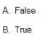
A. False
Q3. True or False: The Crashing is the approach to re-plan the work and try to perform more overlapping sequential activities to be in parallel.
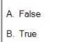
A. False

Q4. True or False: The Project Budget is equal to only the Cost Baseline budget.
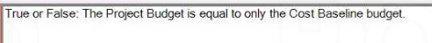
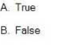
B. False

Q5: True or False: In the context of a project, change is always a bad thing.

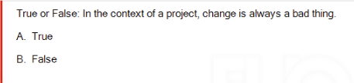

B. False
Q6 True or False: If "review online modules" needs to begin before "develop online modules" can finish, that is called a start to finish relationship.
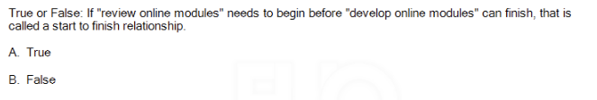
B. False

Q7 True or False: The Fast Tracking is the approach to add more resources (labor, overtime, etc.) into the activities to reduce their durations.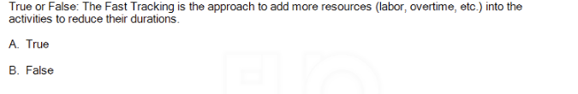
B. False
Q8 True or False: Using top-down estimating techniques when the detail is available and the accuracy is needed. 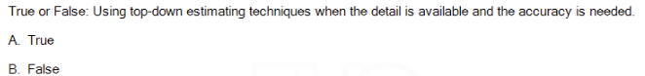
B. False
Q9 True or False: Earned value integrates schedule, budget and quality and uses monetary values to assess project status.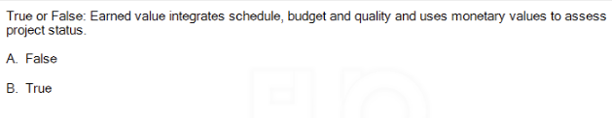
A. False
Earned Value Management (EVM) integrates schedule and budget, but it does not directly incorporate quality into its calculations. EVM focuses on assessing project performance by comparing the planned value (PV), earned value (EV), and actual cost (AC). These metrics are used to evaluate the project's cost and schedule performance, but not its quality. Therefore, the statement is False.

Q10 True or False: Product quality focuses on the project management processes used to meet project objectives
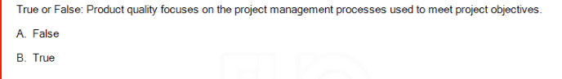
A. False

Q11 True or False: Your role as the project manager during quality control is to work with a representative of quality control department who will create a test plan and test cases which will be used to test the product you are creating in order to prevent defects from reaching your customer.

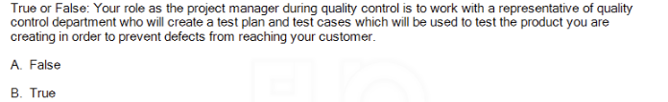
A. False

Q12: True or False: The term resources only refers to people, it does not include money or materials or equipment.
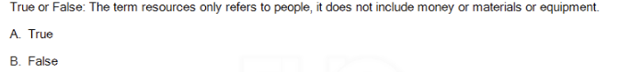
B. False
\ư
Q13. True or False: Performance reporting aims to inform stakeholders the good achievements of the project's objectives weekly or monthly.
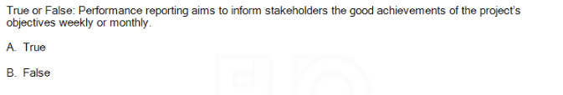
B. False

Explanation: Performance reporting is not solely about informing stakeholders about good achievements. It is about providing a comprehensive view of the project's performance, including progress, risks, issues, and any deviations from the plan, regardless of whether the results are positive or negative. This reporting typically occurs at regular intervals, such as weekly or monthly, and aims to ensure transparency and keep stakeholders informed about all aspects of the project.
Q14 True or False: A positive risk is a threat; a negative risk is an opportunity.
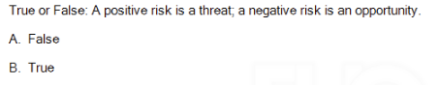
A. False
Q15. True or False: The Project Sponsor is responsible for stakeholder expectations management.
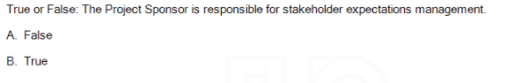
A. False
Q16 : True or False: Scope creep represents the situation that the changes are made with the proper process and authority.
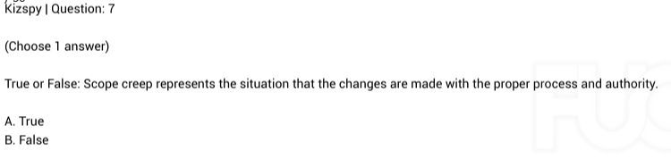
B. False
Q17 : True or False: Unregulated changes allow for innovation and flexibility. Regulating changes causes a lack of creativity.
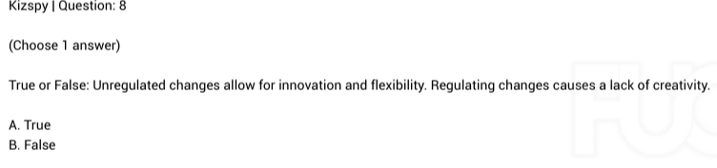
B. False
Q18 True or False: Influence means you have the right to apply resources, make decisions and give approvals.
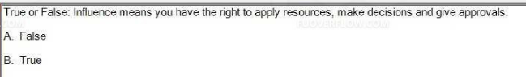
A. False
Q19. True or False: Using bottom-up estimating techniques when activity durations or resource quantities are uncertain.
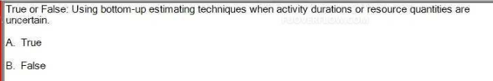
B. False
Q20 True or False: You should use parametric estimating when your historical information used to develop the model was qualitative and not readily quantifiable.
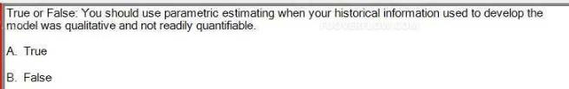
B. False
Q21 True or False: When you are concerned that your estimates might not be correct, especially if you think they are too low, you should pad the estimate and add extra.
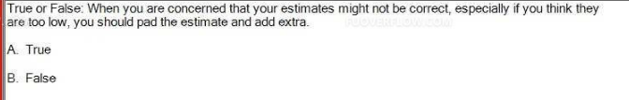
B. False
Q22 True or False: The Process Improvement Plan is a component of the project management plan that details how project management and development processes are to be analyzed in order to identify how to reduce their value.
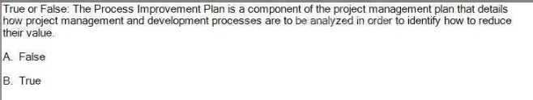
A. False
Q23. True or False: A Project is defined as being unique and temporary, with an undefined start and finish.
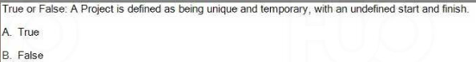
B. False
Q24 -True or False: The Backward Pass is used through the activities to determine the total duration of the project.
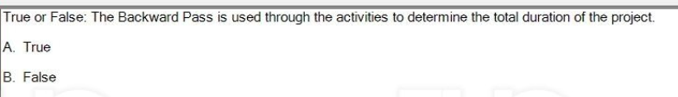
B. False
Q25 True or False: If you want to identify who your stakeholders are, asking who will not be impacted by the product or service being created can be helpful.
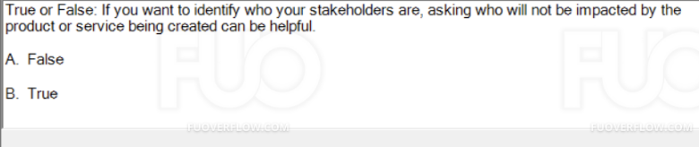
A.False
Q26 True or False: The primary goal of project risk management is to maximize the likelihood and impact of negative events or threats and to minimize the likelihood and impact of positive events or opportunities
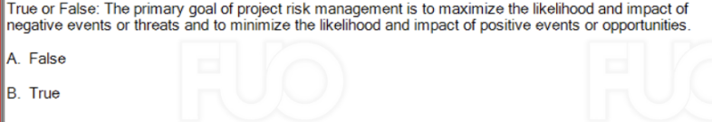
A. False
Q27 True or False: Risk management is one-time process. You need to plan for all possible risks at the project beginning and then follow defined actions to control those risks until they are closed or cancelled.
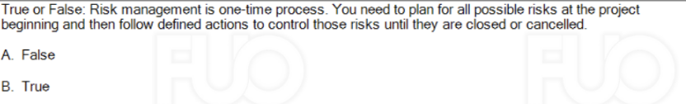A. False
Q28 True or False: The critical path is the shortest path through the network and represents the work that can be delayed without delaying the end of the project.
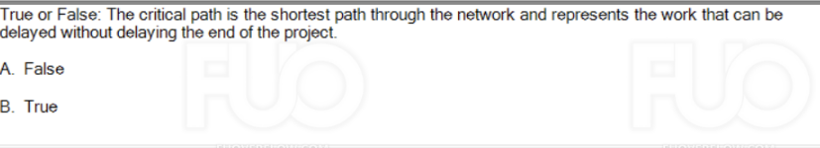
A. False
The critical path is the longest path through the network and represents the work that cannot be delayed without delaying the end of the project.
Q29 True or False: The worst organization to use to run a project will always be the functional organization.
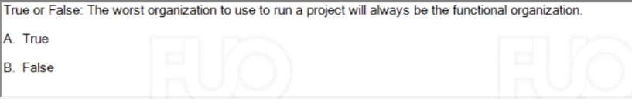B. False
Q30 True or False: A negative risk is an opportunity, a positive risk is a threat.
A. True
B. False

Q31 - True or False: The best organization to use to run a project will always be the projectized organization.

A. True

B. False

Q32 True or False: A Work Breakdown Structure (WBS) is a deliverable-oriented hierarchical decomposition of the work to be executed just by the Project Manager.
A. False
B. True
(100%)

Q33- True or False: In a projectized organization, team members are never assigned to the project full time.
A. False
B. True
(100%)

34 - True or False: Each person involved in the project should be assigned, but doesn't always need to know his or her role and responsibility
A. True
B. False

